### Nodejs 安装部署

<https://nodejs.org/en/download/> 下载地址

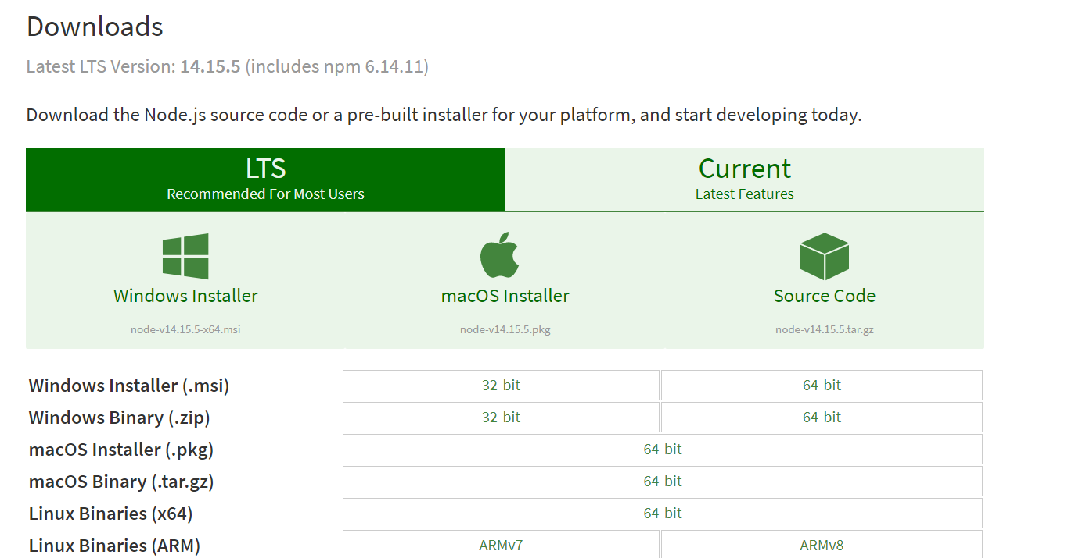

**上图显示当前版本**

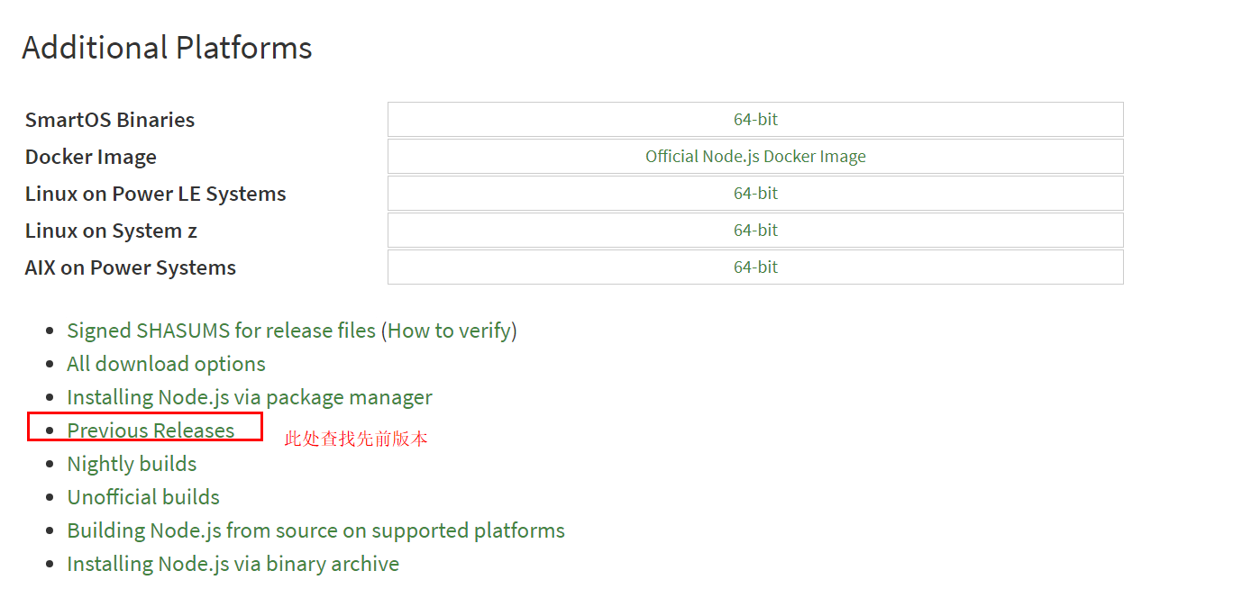

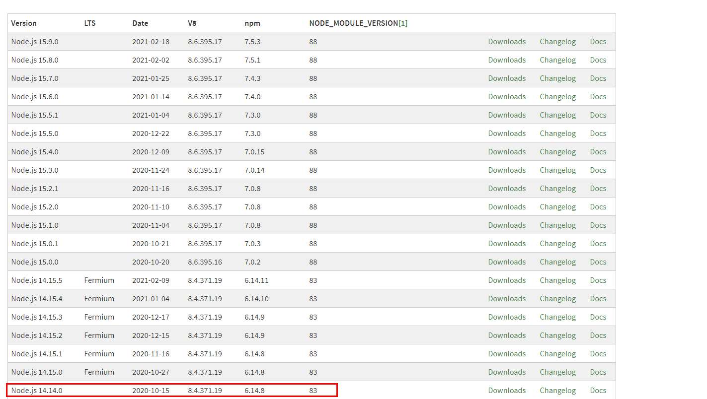

**比如我要找npm版本为6.14.8的**

复制拿到链接，下载nodejs

wget <https://nodejs.org/download/release/v14.14.0/node-v14.14.0-linux-x64.tar.gz>

解压

tar -xvf node-v10.15.3-linux-x64.tar.xz

删除压缩包

rm node-v10.15.3-linux-x64.tar.xz

## **配置环境变量**

编辑

vim /etc/profile

export NODE_HOME=/usr/local/node-v14.14.0

export PATH=$PATH:$NODE_HOME/bin

export NODE_PATH=$NODE_HOME/lib/node_modules

source /etc/profile

检查是否安装成功

node -v

npm -v

有版本号出现则表示成功

***解决 "/lib64/libc.so.6: version `GLIBC_2.18' not found (required by /lib64/libstdc++.so.6)"***

|  |
| --- |
| curl -O http://ftp.gnu.org/gnu/glibc/glibc-2.18.tar.gz  tar zxf glibc-2.18.tar.gz && cd glibc-2.18/  mkdir build && cd build/  ../configure --prefix=/usr  make -j4  make install |